`DIS- Asia-China- Numismatics-spade coin-2

SHAPE \* MERGEFORMAT 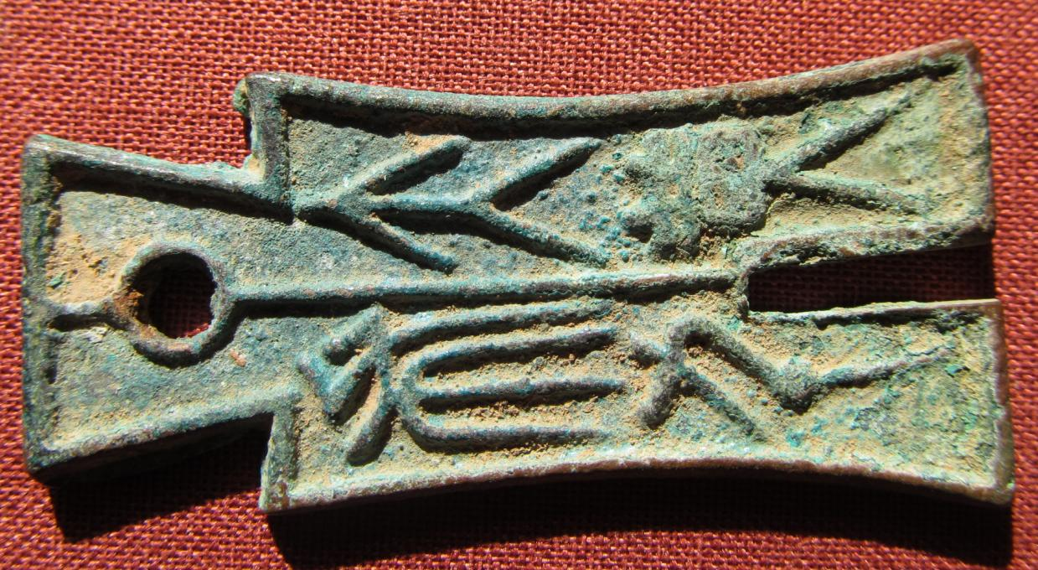 SHAPE \* MERGEFORMAT 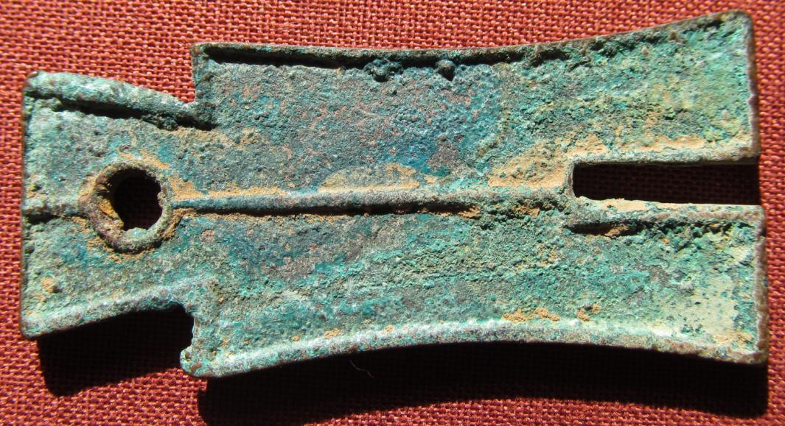

# Da Bu Heng Qian ("Large Spade weight 1000" spade) bronze of Wang Mang (9-23 AD), Xin dynasty (10-14 AD). (Ref.: Hartill 9.29)

Atlantika Collection

Chinese characters divided with a vertical line Da Bu Heng Qian ("Large Spade, weight one thousand"), single inside and outside rim / Single inside and outside rim, long vertical line. 59mm long, 11.85 grams. Very nice green and brown patina with earthen highlights. Schjoth 148; Hartill 9.30.  
The inscription on this coin - "Money Spade", meant that this piece was equal to one older spade coin. These pieces were issued after the monetary reform of 14 AD. It was probably equal to 1000 Huo Quan round coins.  
Wang Mang (45 BC 6 October 23 AD), was a Han Dynasty official who seized the throne from the Liu family and founded the Xin (or Hsin, meaning "new") Dynasty, ruling AD 923. The Han dynasty was restored after his overthrow and his rule marks the separation between the Western Han Dynasty (before Xin) and Eastern Han Dynasty (after Xin). Some historians have traditionally viewed Wang as a usurper, while others have portrayed him as a visionary and selfless social reformer. Though a learned Confucian scholar who sought to implement the harmonious society he saw in the classics, his efforts ended in chaos.  
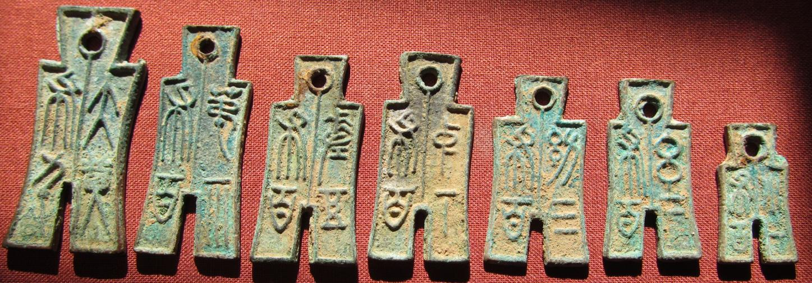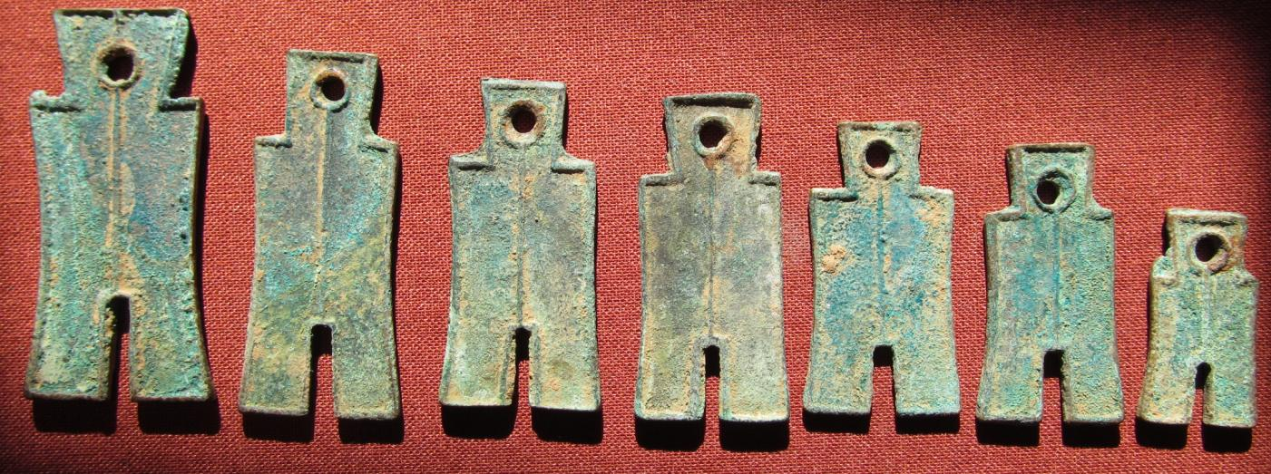

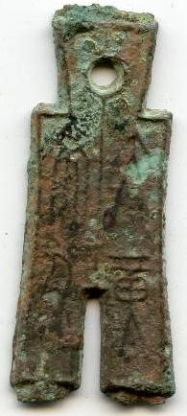 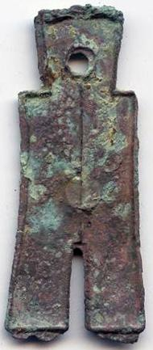

Da Bu Heng Qian ("Large Spade, weight one thousand"), similar specimen sold on EBAY.